EUROPE, MIDDLE EAST AND AFRICA INVOICING
REGION SPECIFIC SUBMISSION REQUIREMENTS

For specific requirements please check information below.

Invoicing methods:

PO | Invoicing method* | Italian supplier invoicing KC s.r.l. | Italian supplier invoicing KC Europe | Ukrainian suppliers
40  41  43  45 | Taulia or PDF sent to Invoice.AP@kcc.com or AP.SouthAfrica@kcc.com(for South Africa only) | Sistema di Interscambio or Taulia | Taulia or PDF sent to Invoice.AP@kcc.com | Existing portals
E | Coupa | Sistema di Interscambio | Coupa | Existing portals

*Saudi Arabia – to use Coupa for Coupa PO type until further notice

COUPA
Invoicing method
Invoice for Coupa PO must be submitted through Coupa.

Italy – invoicing
Italian supplier invoicing Kimberly - Clark Europe with vat registration number IT08077390014 or GB445809527 should use Coupa for invoicing Coupa PO.
Italian supplier invoicing Kimberly - Clark srl with vat registration number IT07629150017 should use Sistema di Interscambio for invoicing Coupa PO.

Ukraine – invoicing
Ukrainian supplier invoicing Kimberly - Clark Ukraine should use existing portals for invoicing Coupa PO.

Out of scope
PO to Pay process for Suppliers providing goods/services for K-C located in Russia, Turkey, and Kazakhstan.

PO on the document
Mandatory

WHT invoice
Invoice must be submitted through Coupa.
Invoices for service PO
For service PO you can invoice more than 1 PO item.

Submission time
The system allows 7 calendar days for submission, calculated back from the invoice date.

Attachments requirements
Compliant template doesn’t require a supplier to upload original invoice. Supplier can attach the original invoice using Attachment feature. Attachment maximum size is 20 MB.
Non - compliant template requires a supplier to upload original invoice using Image scan feature. Attachment maximum size is 20 MB.
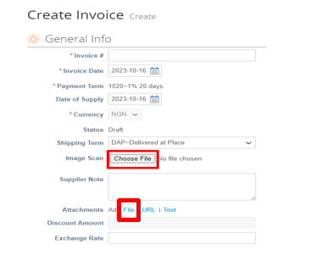
If you will decide to use both feature (attachments and image scan, please name the attachments differently).

Compliant countries – COUPA

COMPLIANT COUPA COUNTRIES |  | NOTE: Suppliers located outside the countries below are called non - compliant in Coupa
EMEA | EMEA | EMEA
Austria | Germany | Slovakia
Bahrain | Greece | Slovenia
Belgium | Ireland | South Africa
Bulgaria | Latvia | Spain
Canary Islands | Lithuania | Sweden
Croatia | Luxembourg | Switzerland
Czech Republic | Norway | The Netherlands
Denmark | Poland | United Arab Emirates
Finland | Romania | United Kingdom
France | Saudi Arabia

cXML supplier
For a cXML supplier, invoices cannot be backdated or sent with a future date as this may cause delay with payments due to KC having to further analyze the root cause.
Special characters
No special characters are supported in the invoice reference field.

Non-complaint template countries
Resolutions not applicable for EMEA where Supplier needs to issue credit note to cancel the invoice:
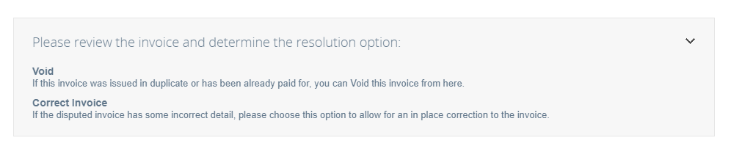
Cash Accounting Scheme Reference
If applicable, please check the box by choosing yes:
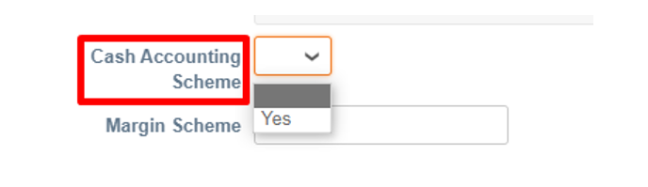

Poland – Split payment mechanism
If applicable, check the box with yes, if not please check the box with no:
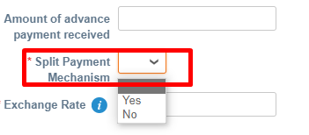

Slovakia – datum dodania (tax reporting date)
Please indicate tax reporting date in the field Date of Supply. Coupa will map this field and shown it as Datum dodania on legal invoice.

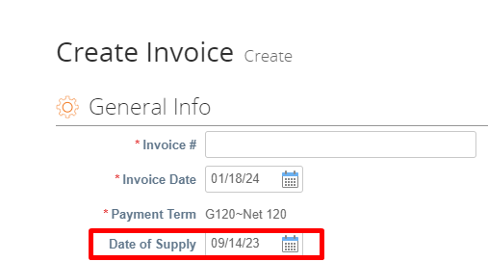

Final invoice view:
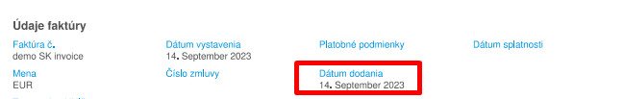
Czech Republic - Datum uskutečnění zdanitelného plnění (tax reporting date)
If you are using Coupa in English: Please indicate tax reporting date in the field Date of Supply. Coupa will map this field and shown it as Datum uskutečnění zdanitelného plnění on legal invoice.
If you are using Coupa in Czech: Please indicate tax reporting date in the field Datum uskutečnění zdanitelného plnění.
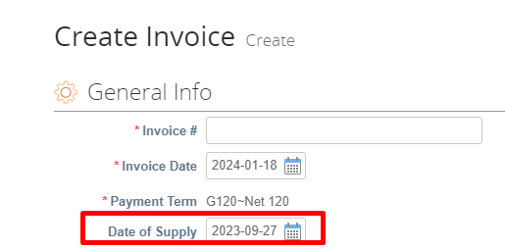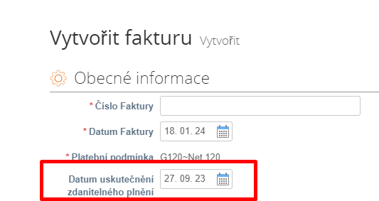

Final invoice view:

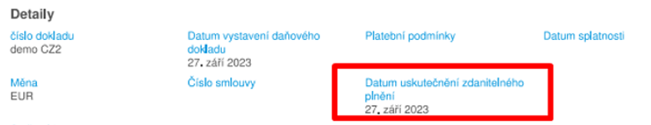

Commodity/Import/HS/TARIC Code
In Commodity/Import/HS/TARIC Code section choose your country first and then proper HS code. If you are not able to find proper HS code, please contact AP or Procurement. After Procuree go – live suppliers are requested to use Procuree for this kind of requests.

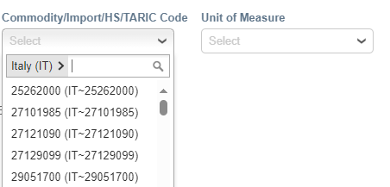
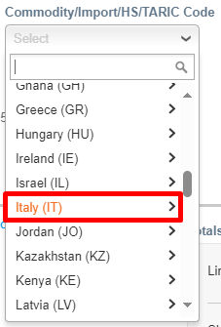

Exchange rate
If this is not a domestic transaction, please provide Exchange Rate.
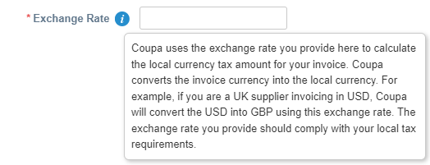
Saudi Arabia – exempt reason
For domestic transaction related to exempt goods and services please check ZATCA mandate and input the correct VAT exemption reason.
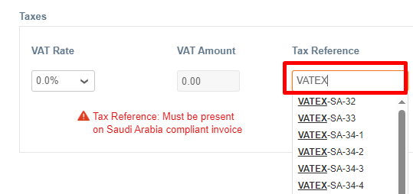

Kenya – Tax rate 16%
For tax rate 16% please chose Tax Rate: 16, manually calculate 14% of the PO line and input this in tax amount field (manually overwriting autofill amount):
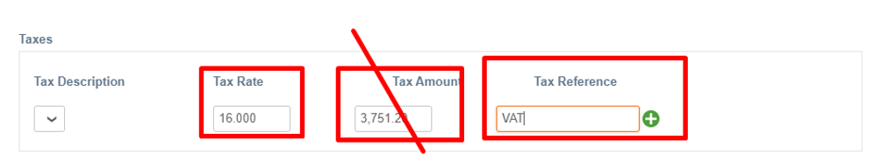
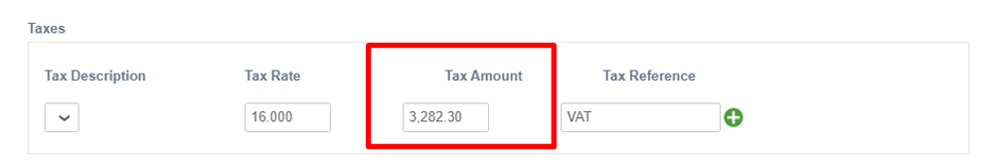

Proforma
Please don’t submit proforma through Coupa. Proforma must be sent directly to your Kimberly – Clark contact person.

Document status
Approved – invoice was received, registered, and awaits due date.
Pending Approval – invoice was received, awaits registration or approval.
Abandoned – cXML invoice was submitted for example with incorrect UOM, initial status will be disputed. Later, status will change to abandoned and you will be asked to submit new invoice once new PO will be created.
Disputed – Disputed reason can contain the action items where K-C will request that the supplier sends additional documentation via Comment section.
The following dispute reasons require a credit note to be submitted by the Supplier: Price Issue, Quantity Issue, Tax Issue, Duplicate invoice, for Incorrect KC VAT registration number, for invoices with 2 PO types (service + goods).
Voided – no action is required from supplier side.

Training materials
Coupa Training Materials (kimberly-clark.com)

How to contact Kimberly - Clark with a Supplier Query
From April 2024 - Submit a query/message through Procuree - link in the Supplier support section of KC Supplier Link Web page.
Source-to-Pay Process (kimberly-clark.com)
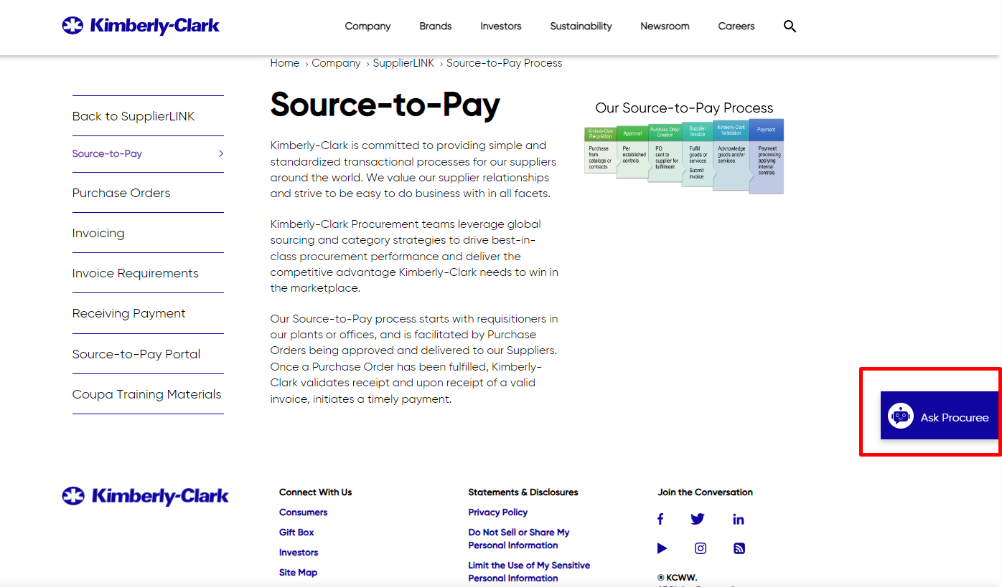

TAULIA
Invoicing method
Invoice must be submitted through Taulia.

WHT invoice
Invoice must be issued by supplier and sent in PDF form to Invoice.AP@kcc.com as withholding tax is not supported by the system.

Italy – invoicing
Invoice must be submitted through Taulia or through Sistema di Interscambio – please choose one method only.

Out of scope
PO to Pay process for Suppliers providing goods/services for K-C located in Russia, Ukraine, Turkey, and Kazakhstan

Attachments requirements
Invoice against a service PO requires supplier to upload a PDF copy of the original invoice using Upload Attachment feature.

Submission time
The system allows 5 calendar days for submission, calculated back from the invoice date.

Special characters
No special characters are supported in the invoice reference field.

Invoices for service PO
For service PO you cannot invoice more than 1 PO item

Document status
Submitting, Incomplete, Rejected, In Process, Approved, Voided, Paid

Training materials
Kimberly-Clark EMEA - English on Vimeo (vimeopro.com)

How to contact Kimberly - Clark with a Supplier Query
Supplier will submit the message through Taulia message board using the "Send message" option or use the following email address KC.P2PPortal_EMEA@kcc.com

From April 2024 - Submit a query/message through Procuree - link in the Supplier support section of KC Supplier Link Web page: Source-to-Pay Process (kimberly-clark.com)

SAP PO
Invoicing method
Invoice must be issued internally by supplier and send in PDF form to Invoice.AP@kcc.com

PO on the document
PO number must be stated on invoice to avoid possible processing and payment delays.

WHT invoice
Invoice must be issued internally by supplier and send in PDF form to Invoice.AP@kcc.com

Italy – invoicing
Invoice must be submitted through Sistema di Interscambio only.
Exception: regime forfettario – invoice must be issued internally by supplier and send in PDF form to Invoice.AP@kcc.com

Ukraine – invoicing
Invoice must be submitted through existing portals.

Attachments requirements
Sending invoices to Invoice.AP@kcc.com please make sure that file formats must either be .PDF or .TIFF. Any other file format will be rejected. Each file / attachment must contain only one invoice along with any supporting documentation. If a single invoice is sent in separate files, they will not be merged into one. If a file contains more than one invoice it will not be split but treated as one invoice.
How to contact Kimberly - Clark with a Supplier Query
From April 2024 - Submit a query/message through Procuree - link in the Supplier support section of KC Supplier Link Web page.
Source-to-Pay Process (kimberly-clark.com)

Freight Suppliers
Invoicing method
Invoice must be issued internally by supplier and send in PDF form to Invoice.AP@kcc.com or AP.SouthAfrica@kcc.com (for South Africa only).

Italy – invoicing
Italian supplier invoicing Kimberly - Clark Europe with vat registration number IT08077390014 or GB445809527 should send invoice in PDF form to Invoice.AP@kcc.com
Italian supplier invoicing Kimberly - Clark srl with vat registration number IT07629150017 should send invoice through Sistema di Interscambio.

Ukraine – invoicing
Invoice must be submitted through existing portals.

Attachments requirements
Sending invoices to Invoice.AP@kcc.com please make sure that file formats must either be .PDF or .TIFF. Any other file format will be rejected. Each file / attachment must contain only one invoice along with any supporting documentation. If a single invoice is sent in separate files, they will not be merged into one. If a file contains more than one invoice it will not be split but treated as one invoice.

How to contact Kimberly - Clark with a Supplier Query
From April 2024 - Submit a query/message through Procuree - link in the Supplier support section of KC Supplier Link Web page.
Source-to-Pay Process (kimberly-clark.com)

Requirements summary
Country | Invoice ingestion channel | Original invoice attachment | Submission time | Special characters in the reference field
Ukraine | existing portals | N/A | local regulations | local regulations
Italy (invoicing Kimberly - Clark s.r.l. vat registration number IT07629150017) | Sistema di Interscambio | N/A | local regulations | local regulations
Italy (invoicing Kimberly - Clark Europe vat registration number IT08077390014 or GB445809527) | COUPA | optional | 7 calendar days, calculated back from the invoice date | not allowed
Nigeria | COUPA | mandatory | 7 calendar days, calculated back from the invoice date | not allowed
Kenya | COUPA | mandatory | 7 calendar days, calculated back from the invoice date | not allowed
Portugal | COUPA | mandatory | 7 calendar days, calculated back from the invoice date | not allowed
Austria | COUPA | optional | 7 calendar days, calculated back from the invoice date | not allowed
Bahrain | COUPA | optional | 7 calendar days, calculated back from the invoice date | not allowed
Belgium | COUPA | optional | 7 calendar days, calculated back from the invoice date | not allowed
Bulgaria | COUPA | optional | 7 calendar days, calculated back from the invoice date | not allowed
Canary Island | COUPA | optional | 7 calendar days, calculated back from the invoice date | not allowed
Croatia | COUPA | optional | 7 calendar days, calculated back from the invoice date | not allowed
Czech Republic | COUPA | optional | 7 calendar days, calculated back from the invoice date | not allowed
Denmark | COUPA | optional | 7 calendar days, calculated back from the invoice date | not allowed
Finland | COUPA | optional | 7 calendar days, calculated back from the invoice date | not allowed
France | COUPA | optional | 7 calendar days, calculated back from the invoice date | not allowed
Germany | COUPA | optional | 7 calendar days, calculated back from the invoice date | not allowed
Greece | COUPA | optional | 7 calendar days, calculated back from the invoice date | not allowed
Hungary | COUPA | optional | 7 calendar days, calculated back from the invoice date | not allowed
Ireland | COUPA | optional | 7 calendar days, calculated back from the invoice date | not allowed
Latvia | COUPA | optional | 7 calendar days, calculated back from the invoice date | not allowed
Lithuania | COUPA | optional | 7 calendar days, calculated back from the invoice date | not allowed
Luxembourg | COUPA | optional | 7 calendar days, calculated back from the invoice date | not allowed
Norway | COUPA | optional | 7 calendar days, calculated back from the invoice date | not allowed
Poland | COUPA | optional | 7 calendar days, calculated back from the invoice date | not allowed
Romania | COUPA | optional | 7 calendar days, calculated back from the invoice date | not allowed
Saudi Arabia | COUPA | optional | 7 calendar days, calculated back from the invoice date | not allowed
Serbia | COUPA | optional | 7 calendar days, calculated back from the invoice date | not allowed
Slovakia | COUPA | optional | 7 calendar days, calculated back from the invoice date | not allowed
Slovenia | COUPA | optional | 7 calendar days, calculated back from the invoice date | not allowed
South Africa | COUPA | optional | 7 calendar days, calculated back from the invoice date | not allowed
Spain | COUPA | optional | 7 calendar days, calculated back from the invoice date | not allowed
Sweden | COUPA | optional | 7 calendar days, calculated back from the invoice date | not allowed
Switzerland | COUPA | optional | 7 calendar days, calculated back from the invoice date | not allowed
The Netherlands | COUPA | optional | 7 calendar days, calculated back from the invoice date | not allowed
United Arab Emirates | COUPA | optional | 7 calendar days, calculated back from the invoice date | not allowed
United Kingdom | COUPA | optional | 7 calendar days, calculated back from the invoice date | not allowed

